A Heterogeneous Wireless Video Surveillance System Based on Pub/Sub and Composite Event Detection
Author 1  Stanford University  abby@bank-acm.edu | Author 2  Stanford University/ Intuit  burt@institution.edu | Author 3  Stanford University  jones@school.edu | Author 4  Stanford University / Google  ross@affiliation.com

ABSTRACT

Copyright is held by the author/owner(s).
UbiComp’11, September 17–21, 2011, Beijing, China.
ACM 978-1-60558-843-8/10/09.

传统的video surveillance 系统，绝大部分是基于有线，并且利用人工来进行监测。有线的部署成本高，覆盖范围有线。利用人工来进行监测，不仅耗费极大的人力，并且容易漏掉关键事件。
因此，我们建立起一套基于pub-sub的无线监测系统。该系统为heterogeneous 架构，底层利用WSN，来检测用户自己定义的感兴趣的事件。上层利用WMN,在底层检测到信号之后，启动摄像头来传输相关的视频信号。利用无线系统避免了有线的布设，极大的节约了成本，并且用户可以灵活定制事件，并且是触发式的实施对定义的事件的监测。
该系统的challenging issue 在于1. 如何将WSN和WMN结合起来。2 在底层，如何用WSN来检测复合事件。特别考虑到WSN节点能量有限，如何以分布式的方式检测到用于定义的复合事件是一个重要的问题。
在本demo中，我们将会介绍该系统的硬件平台，软件平台。
The rapid development of ubiquitous computing raises the requirement on the convergence of heterogeneous wireless accessing technologies. New applications have been developed based on these technologies. In order to ensure the smooth interaction among these applications, middleware plays an important role.
In this demo, we illustrate a multi-tiered WMN (wireless mesh network)-WSN (wireless sensor network) architecture to support various multi-media applications. The WMN testbed, acting as the wireless backbone, supports high quality audio/video/data streams based on multi-radio and multi-channel technique, and can securely and seamlessly integrate with WiFi and 3G networks based on optimization in the layer 2 and 3. The WSN testbed detects events from various of sensors, including vibration, location and image. By taking advantage of distributed processing, WSN can efficiently filter the events and deliver those which are needed by applications. It also provides a high level abstraction so that events may be defined and subscribed in an easy way.
The integration of these two wireless network technologies significantly eliminates the deficiency of traditional one-tier WSN in terms of generated data volume, mobility characteristic, priority, delay constraints, and energy supply. In one direction, WMN helps WSN to deliver data to the backend server with high speed and robustness guarantee; and in another way, WSN provides publish / subscribe (pub/sub) services which simplify event processing for the higher level. The demonstration is concluded with two representative applications: wireless video surveillance and structure health monitoring. Both demos show the effectiveness of the proposed architecture.

Author Keywords Wireless Sensor Networks, Zigbee, WiFi

ACM Classification Keywords C.2.1 [Network Architecture and Design]: Wireless communication

General Terms Design

INTRODUCTION

传统的video surveillance 系统，绝大部分是基于有线，并且利用人工来进行监测。有线的部署成本高，覆盖范围有线。利用人工来进行监测，不仅耗费极大的人力，并且容易漏掉关键事件

因此，我们建立起一套基于pub-sub的无线监测系统。该系统为heterogeneous 架构，底层利用WSN，来检测用户自己定义的感兴趣的事件。上层利用WMN,在底层检测到信号之后，启动摄像头来传输相关的视频信号。利用无线系统避免了有线的布设，极大的节约了成本，并且用户可以灵活定制事件，并且是触发式的实施对定义的事件的监测。
系统的硬件平台：
底层：WSN sensor node
上层： mesh router
中间层： gateway

系统的软件平台：
底层：composite event detection
上层： routing layer of mesh router

The traditional solution for interconnecting two different network types is use of a gateway device. A gateway is a multi-interface network node, which has the necessary protocols installed to communicate with both network types. In case of WSN and WMN networks, a simple gateway strategy is depicted in Figure 2. In this scenario, all sensors propagate their values towards a central gateway device, which acts as a sink for the sensor network. The gateway devices stores all received sensor values in a database. With a single gateway for interconnection, the system is not scalable and the gateway node also may become a bottle neck nodes.

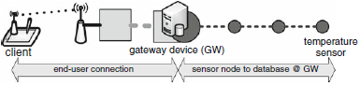
Figure 2. Traditional single gateway solution for information exchange between WSNs and WMNs
我们系统的特点：
特点1： 结合WSN和WMN，底层用WSN来检测事件，上层用WMN来传输视频流。
特点2： 在WSN层面利用composite event detection,
Our strategy of interconnecting the WSNs and the WMNs is using a multi-gateway structure to construct a scalable heterogeneous network, which is also introduced in Error: Reference source not found. But in our system we do not require any kind of packet format translation.
On the low level of this network architecture, we have WSN providing composite event services. In particular, we use a middleware architecture named PSWare. PSWare features a layered design. On the top layer, it provides Event Definition Language (EDL) so that applications can easily define and subscribe to events. On the bottom layer, it uses a runtime environment so that different composite event detection mechanisms may be easily integrated. The figure below shows the basic operation for PSWare. Application will first define the events using EDL. Then the event definition will be compiled and disseminated into the network and installed on each sensor node. Once the subscribed events are detected, the events will be delivered to the application.
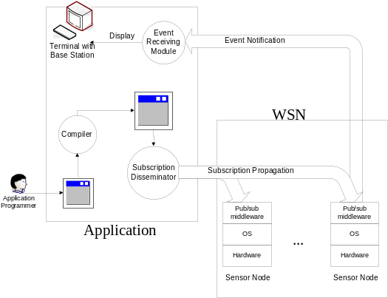

We use the wireless mesh nodes to form the Pub/Sub broker overlay network for mobile client to register the subscriptions. We use TelosB mote as gateway node and every TelosB mote will connect with a batch of MicaZ motes to form a small cluster for event detection. Every small cluster is used for sensing data in one particular area.
Every TelosB gateway node is attached to a mobile wireless device (notebook), which is a client connecting to the wireless mesh networks.
Mesh Nodes
Sensor Nodes
Mesh Routing
Gateway Nodes
Figure 3. Communications between WSNs and WMNs

With such network hierarchy (see Figure 3), the WSN is invisible to the upper layer mesh nodes. Every sensor cluster can be addressed with an IP address of the mobile device that the TelosB gateway attached. The underlying WSN does not require to directly access to the WMN nodes and all the WSN packets within a cluster are just collected by the TelosB gateway nodes. The TelosB gateway can interact with other TelosB gateway nodes through the mesh route path by using socket communication.

系统的演示：

REFERENCES
- It is recommended to have the references/citations ragged right/flush left. This way items with long string urls (web addresses) do not cause lines or entries to be letter and word spaced.
- Adobe Acrobat Reader.
http://get.adobe.com/reader/
- Anderson, R.E. Social impacts of computing: Codes of professional ethics. Social Science Computing Review 10, 2 (1992), 453-469.
- Nara To-kae, Japan, http://www.toukae.jp/tokae_e/index.html
- How to Classify Works Using ACM’s Computing Classification System.
http://www.acm.org/class/how_to_use.html.
- Klemmer, R.S., Thomsen, M., Phelps-Goodman, E., Lee, R. and Landay, J.A. Where do web sites come from? Capturing and interacting with design history. In Proc. CHI 2002, ACM Press (2002), 1-8.
- Wollscheid, A., Frankfurt, Germany, http://www.selektion.com/members/wollscheid/default.htm

BALANCE THE LAST PAGE INTO TWO AS EVEN COLUMNS AS POSSIBLE, BY NOT DELETING THIS LINE, JUST DELETE THE TEXT.

